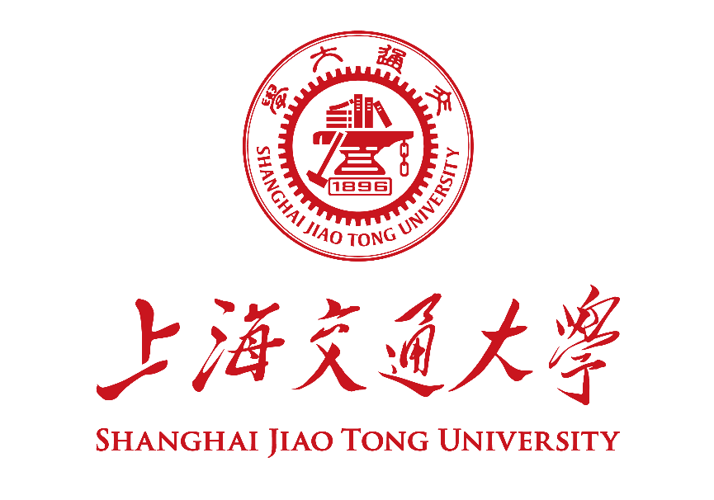
博士研究生学位论文年度进展报告
Annual Progress Report for SJTU Doctoral Student

学号 Student ID：
姓名 Name:
导师 Supervisor(s):
专业 Major:
学院 School:
入学方式 Enrollment: | 选择一项。
学生类别 Degree Program: | 选择一项。
考核日期 Date:

填 报 说 明
Instruction
- 博士研究生年度进展报告应通过数字交大在线提交申请，填写本表并上传系统。特殊情况下经研究生院事先同意，可不上传系统，并使用《上海交通大学博士研究生年度进展报告评审表》完成评审。
The application for thesis/dissertation work annual progress review should be submitted online through My SJTU. The student shall filled this form and upload it in the system. Under special circumstance, this form does not need to be uploaded and the review can be proceeded with the review form with prior consent from the graduate school.
- 本报告应A4纸双面打印，于左侧钉在一起。各栏空格不够时，请自行加页。考核前提前一周送交导师、评审专家审阅。
This report should be printed with A4 papers and bound together on the left. If the space left is not enough, please feel free to add extra pages. The print version shall be sent to the supervisor, and the review committee members for review at least one week before the oral presentation.
- 年度进展报告通过后，定稿版报告由研究生、导师各存档一份，无需上传系统。
Upon passing the review, the final version of this report shall be archived by the graduate student and his/her supervisors for future reference.

博士生年度进展报告 Annual Progress Report
论文题目
Dissertation Title
研究课题来源  Source of Research Project | 请在合适选项前画√ Please select the proper options by “√”.  ☐ 国家自然科学基金课题 NSFC Research Grants  ☐ 国家社会科学基金 National Social Science Fund of China  ☐ 国家重大科研专项 National Key Research Projects  ☐ 其它纵向科研课题 Other Governmental Research Grants  ☐ 企业横向课题 R&D Projects from Industry  ☐ 自拟课题 Self-proposed Project
论文开题日期
Dissertation Proposal Date
- 报告正文 Report。请阐述开题报告或上次年度进展报告以来学位论文研究工作的进展情况及所取得的阶段性成果，并简述下一年度研究计划，不少于3,000汉字。Please summarize your research progress and achievements since your dissertation proposal or last annual progress review, as well as your plan for next step. No less than 2,400 words if written in English.

- 成果清单 List of Achievements。请列出开题报告以来或上次年度进展报告以来新发表的学术论文、授权专利、国际会议论文、专著等成果清单。作者、标题、杂志、卷、期、页码等信息请填写完整。Please provide a list of academic publications (papers, patents, international academic conference talks, monographs, etc.) since your dissertation proposal or last annual progress review. Information on author list, title, journal name, volume, number, and pages shall be complete.

本人承诺：报告中的内容真实无误，若有不实，愿承担相应的责任和后果。I hereby declare and confirm that the details provided in this Form are valid and accurate. If anything untruthful found, I will bear the corresponding liabilities and consequences.

学生签字/Signature of Student： 日期/Date： 2020-12-21

